Connecting to the Virtual Lab Environment

You only need to redeem the training key one time.

1. The training key will be provided by the instructor before class.
2. Navigate to <https://aka.ms/LearningCampus>
3. Sign in with your Microsoft account not your Corporate AAD account
   * If you do not have a Microsoft account, then create it here: [http://live.com](https://outlook.live.com/owa/)

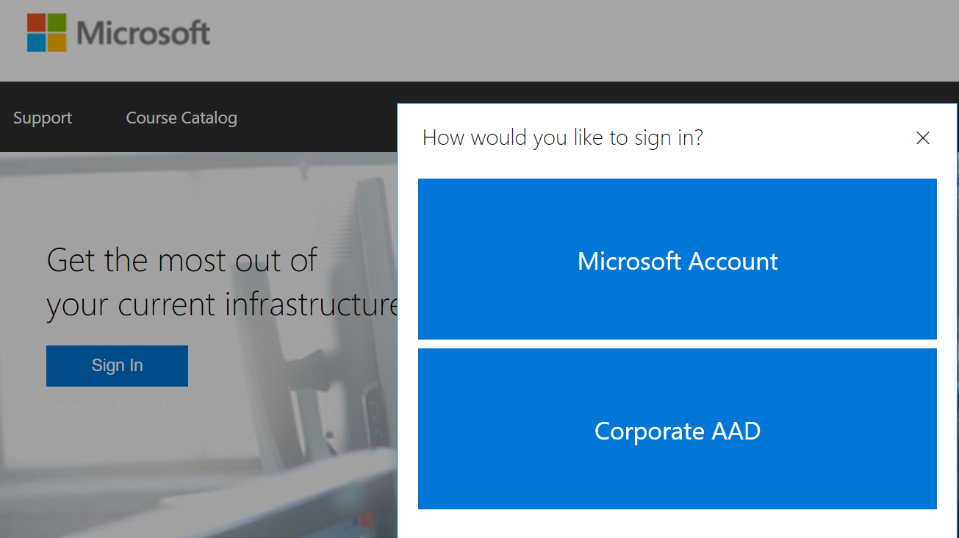

1. Select WorkshopPlus from the navigation bar and click on My TrainingGraphical user interface, text

   Description automatically generated
2. Select Redeem Training Key. Text

   Description automatically generated with medium confidence
3. Enter Training Key. Graphical user interface, application

   Description automatically generated with medium confidence
4. To access the virtual labs, Select WorkshopPlus and click on My Training. Graphical user interface, text, application

   Description automatically generated
5. Click on the Name of your class. 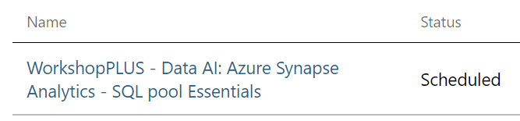
6. Click Launch to start Virtual Machine. Graphical user interface, text, application, email

   Description automatically generated